**COVID-19 Data exploration using SQL (SQL Server) – Global and Greece Data Exploration**

# Dataset

The data for this project is taken from [Our World in Data](https://ourworldindata.org/coronavirus) (free resource to obtain public datasets).

Data fields description can be found in

https://github.com/owid/covid-19-data/tree/master/public/data/

and

https://github.com/owid/covid-19-data/blob/master/public/data/owid-covid-codebook.csv

The project contains an in-depth analysis of Covid Cases, implemented using Excel, SQL and the next stage will be the visualization using Tableau.

The SQL analysis is implemented on Microsoft SQL Server.

The table used for this analysis contains data from the beginning of the Pandemic till 20th March 2023.

After downloading the data (one csv file), the file imported into Excel. I deleted irrelevant columns, and the dataset was split into two tables so JOINs, etc. to be performed (cov19deaths and cov19vaccinations).

The columns from original table imported to SQL Server in table [cov19deaths] are:

[iso_code] ,[continent],[location],[date],[population],

[total_cases],[new_cases], [total_deaths],[new_deaths]

The columns from original table imported to SQL Server in table [cov19vaccinations] are:

[iso_code],[continent],[location],[date],

[total_tests],[new_tests],[positive_rate],

[total_vaccinations],[people_vaccinated],

[people_fully_vaccinated],[new_vaccinations]

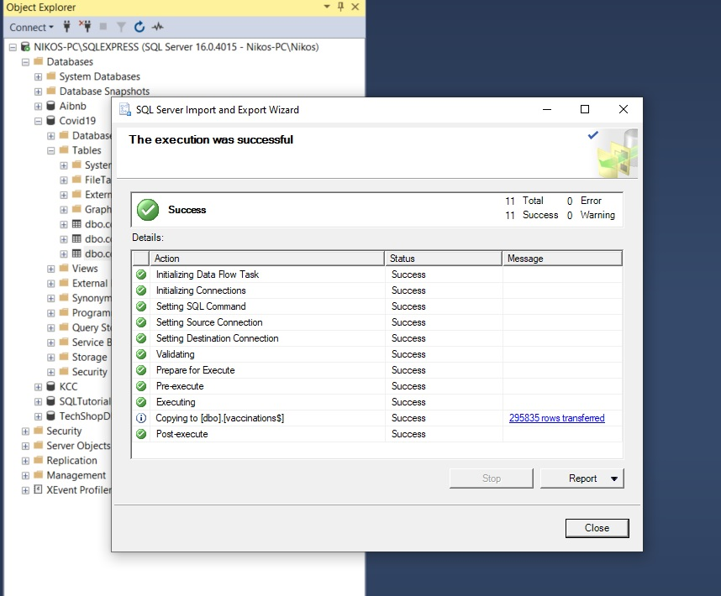

Import table vaccinations

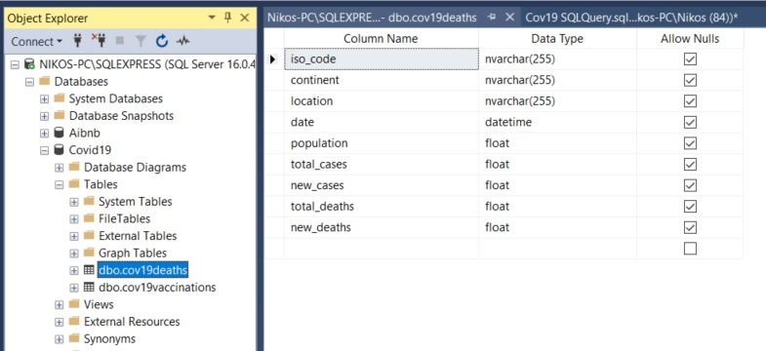

Design of table dbo.covid19deaths

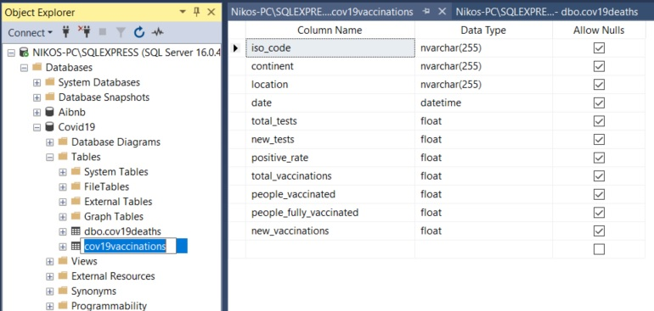

Design of table dbo.covid19vaccinations

exploring data

Below is a snapshot of a few of the queries and results from the Covid19 dataset.

The SQL query file will be available on my Github Repo: https://github.com

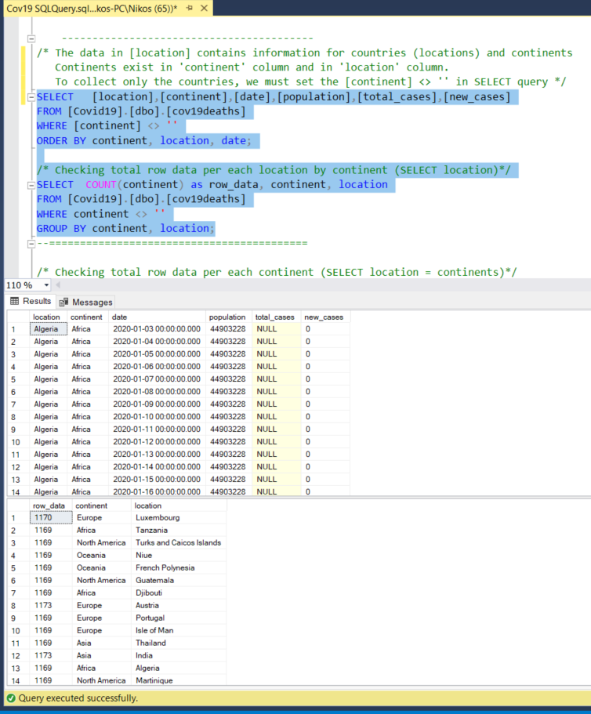

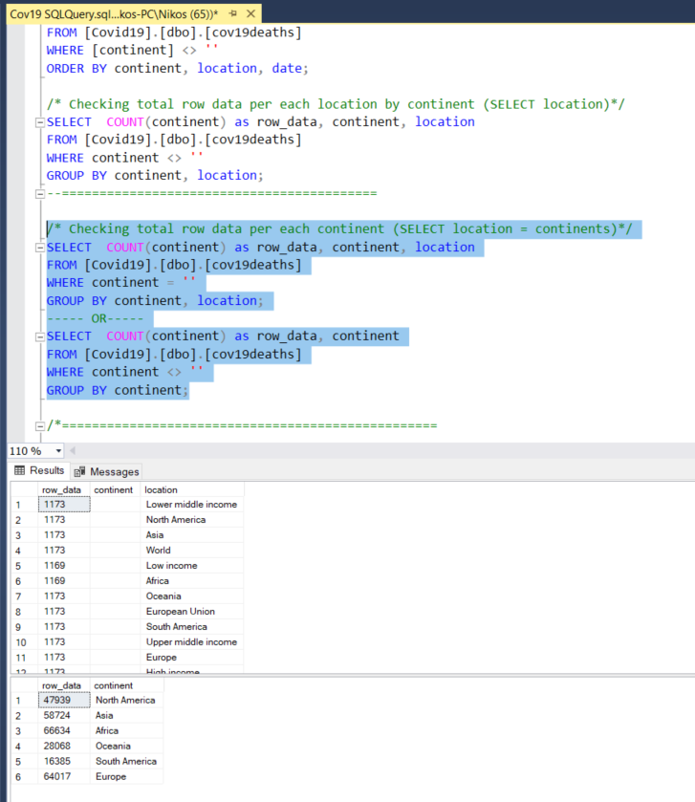

**Data about Deaths, infections**

/* Find how many and the day that each Country has the first case(s) of covid-19 */

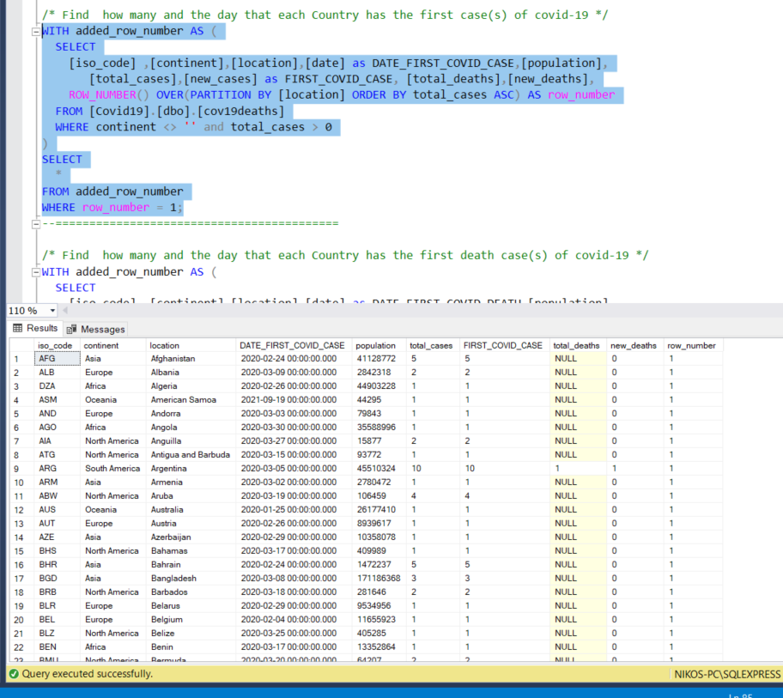

the first case(s) of covid-19 by country

/* Find how many and the day that each Country has the first death case(s) of covid-19 */

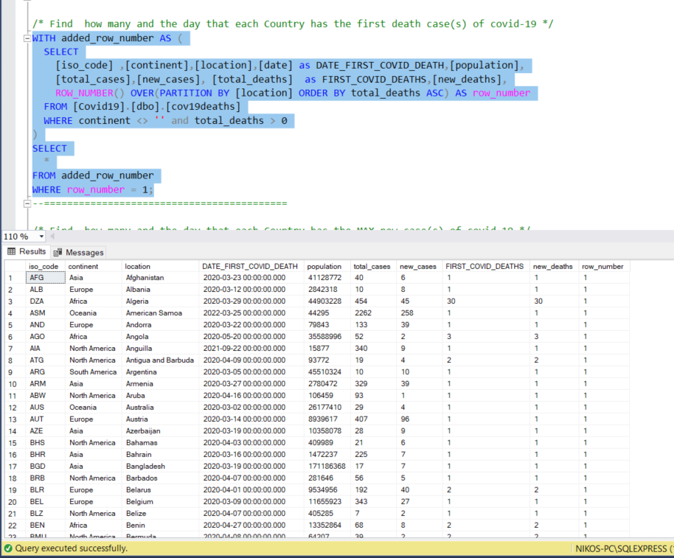

the first death case(s) of covid-19 by country

/* Find how many and the day that each Country has the MAX new case(s) of covid-19 */

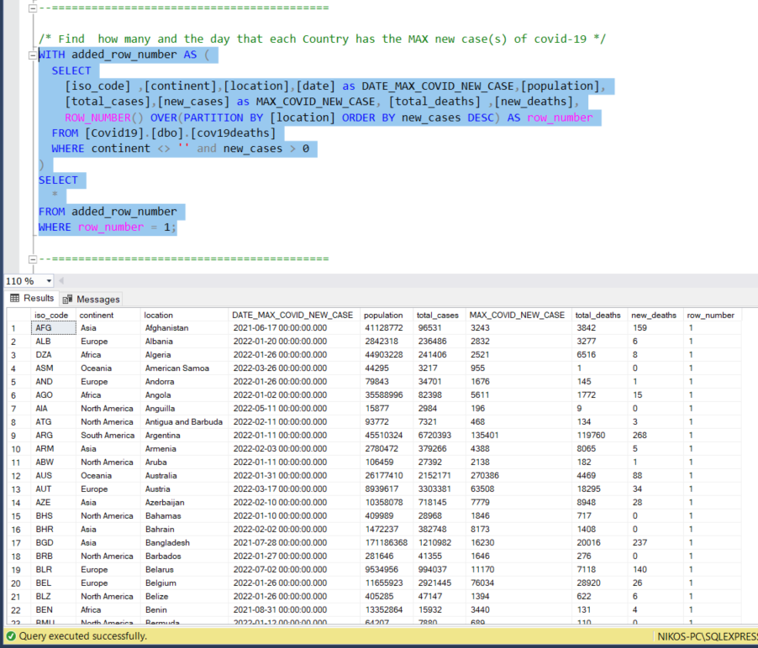

the MAX new case(s) of covid-19 by country

/* Find how many and the day that each Country has the MAX new deaths of covid-19 */

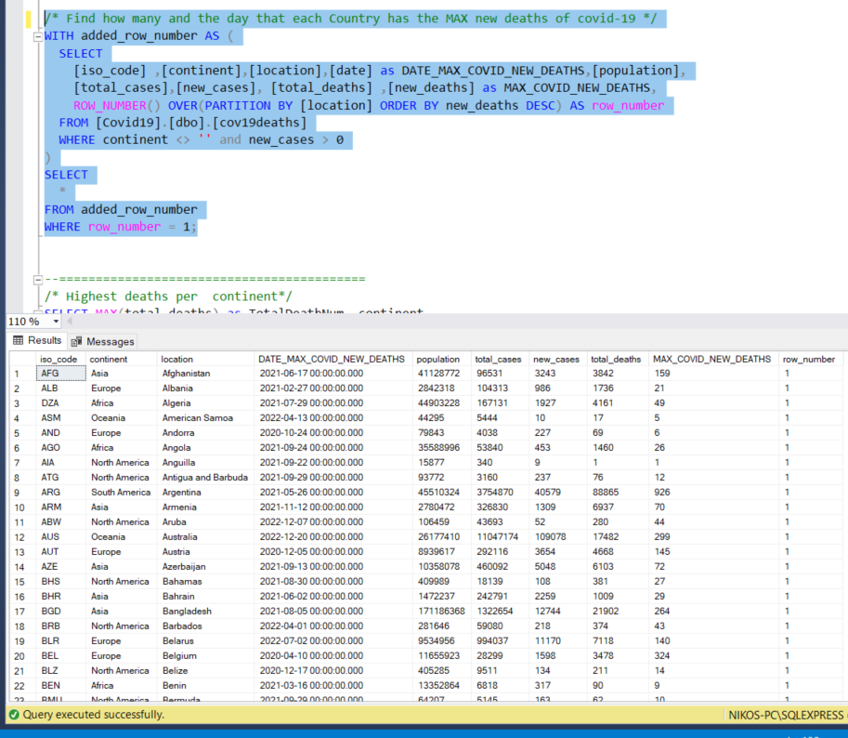

the MAX new deaths of covid-19 by country

/* Find Total deaths per continent*/

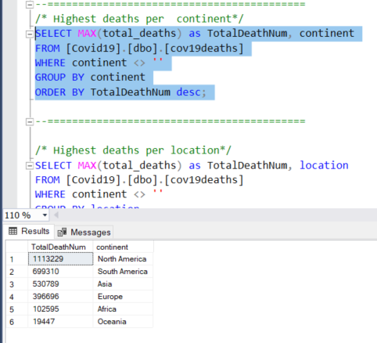

Total deaths per continent

/* Highest deaths per location*/

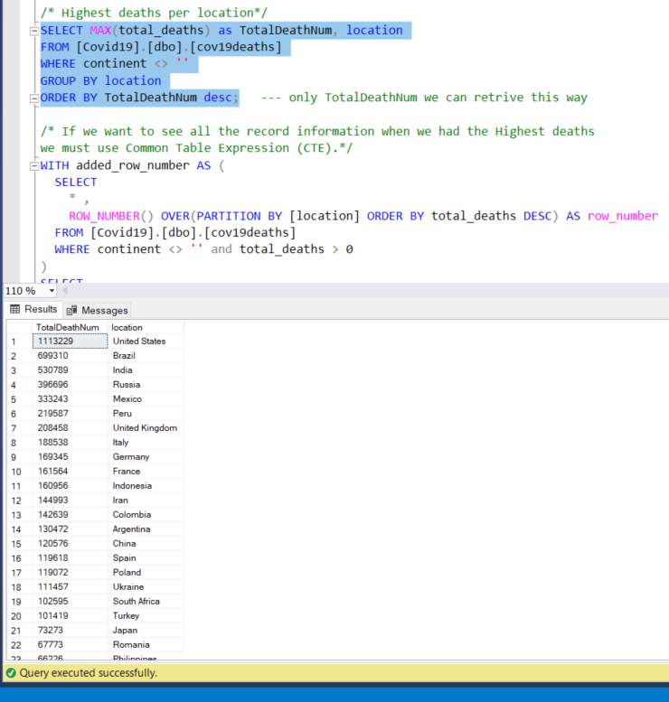

Total deaths per country

/* Find World Totals */

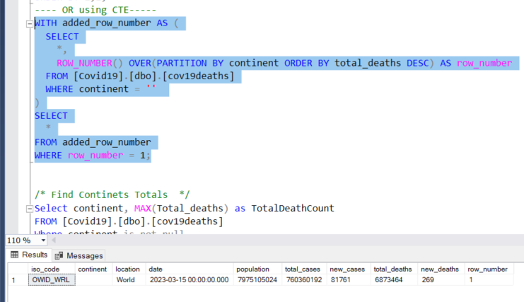

World totals

/* Find Continets Totals */

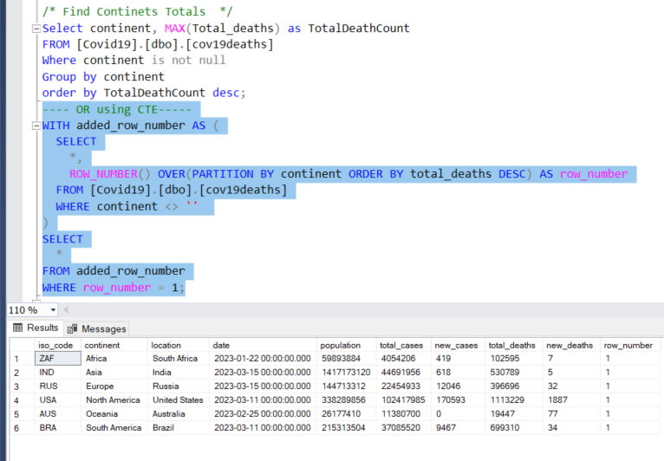

Continents total

**Data about Vaccinations**

/* Find how many and the day that each Country had the first people vaccinated*/

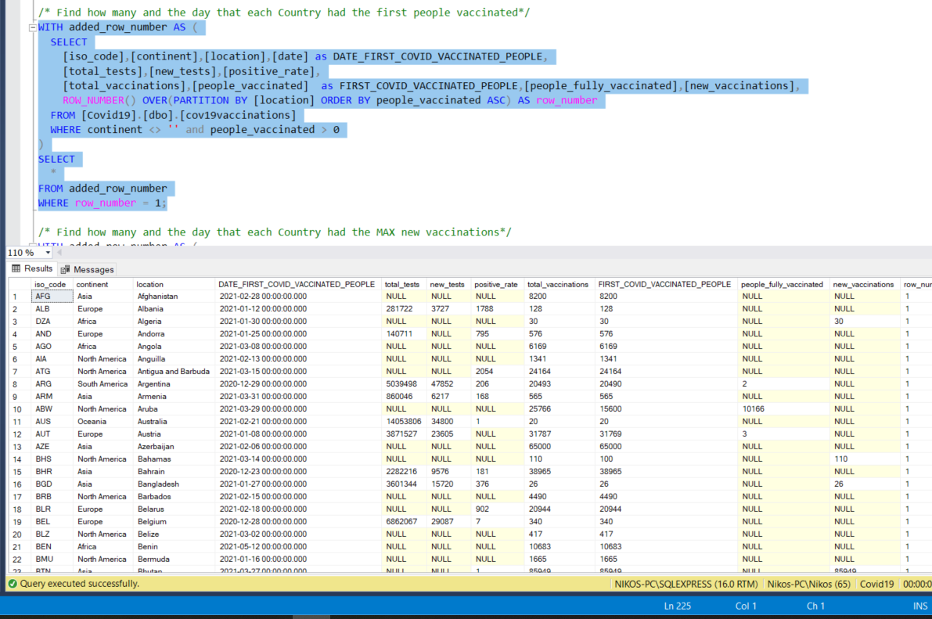

the first people vaccinated case(s) by country

/* Find how many and the day that each Country had the MAX new vaccinations*/

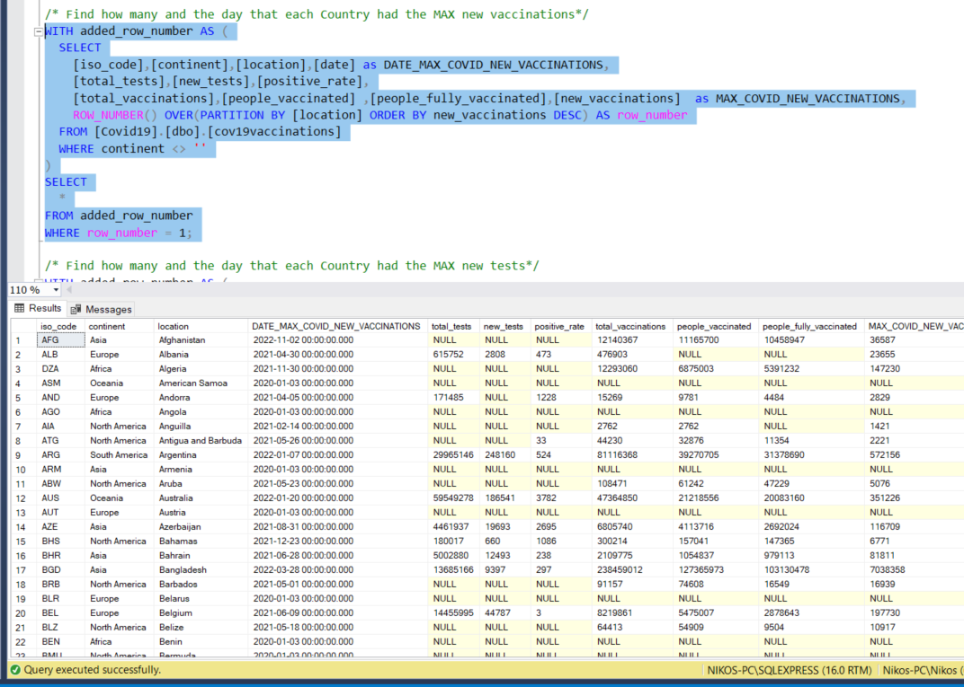

the MAX new vaccinations case(s) by country

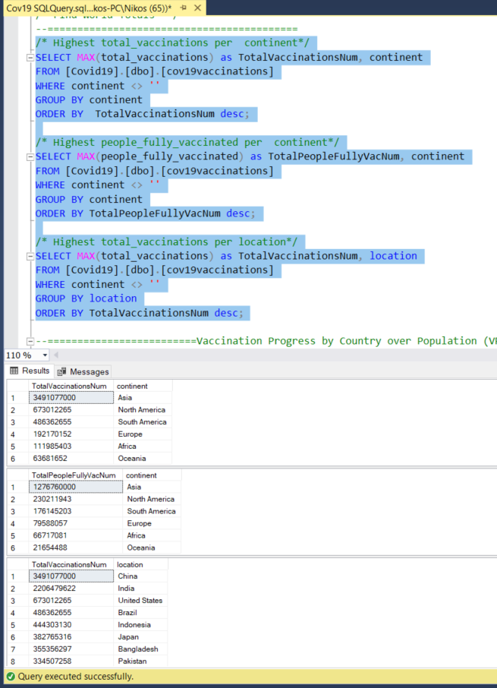

Total Vaccinations Cases by Country

Vaccination Progress by Country over Population (VPOP)

Vaccinated People & Fully Vaccinated People Increment

Percentage of Population that has been Vaccinated OR Fully Vaccinated

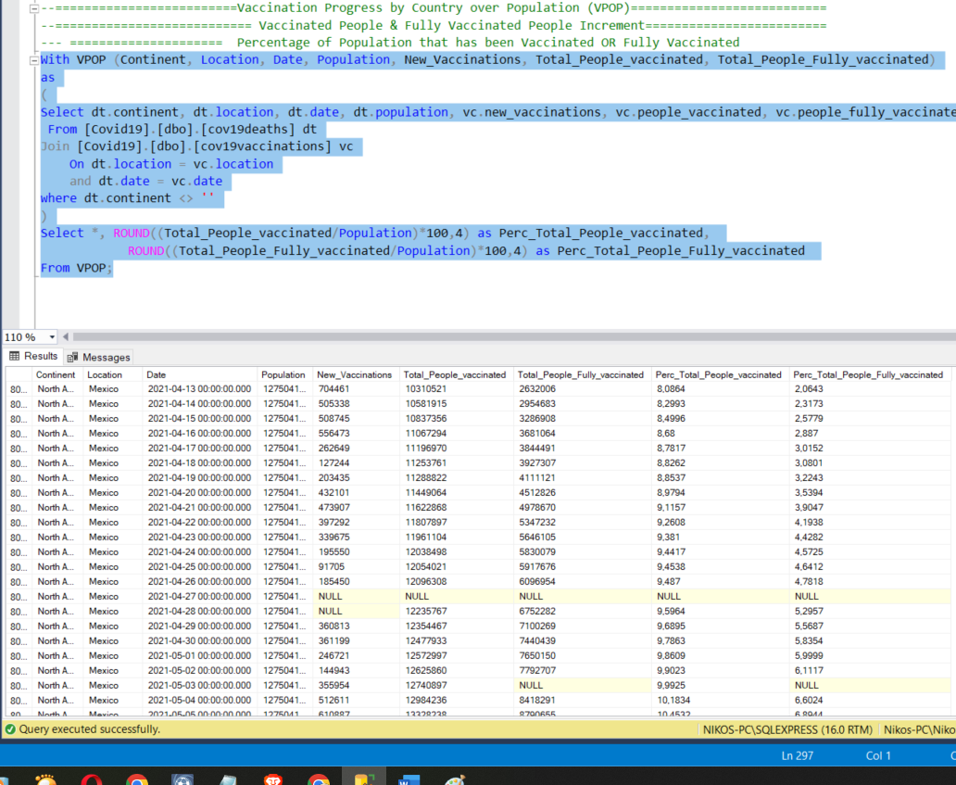

Percentage of Population that has been Vaccinated OR Fully Vaccinated

**Greece Data Exploration**

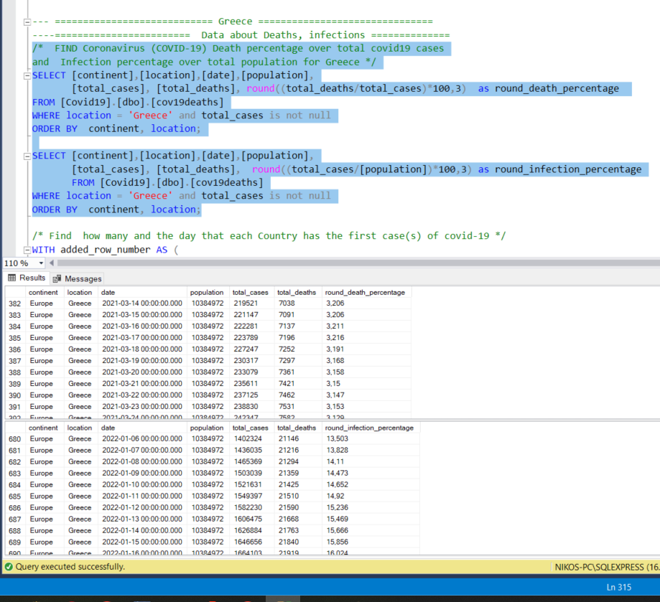

/* Find how many and the day that Greece has the first case(s) of covid-19 */

/* Find how many and the day that Greece has the first death case(s) of covid-19 */

/* Find how many and the day that Greece has the MAX new case(s) of covid-19 */

/* Find how many and the day thatGreece has the MAX new deaths of covid-19 */

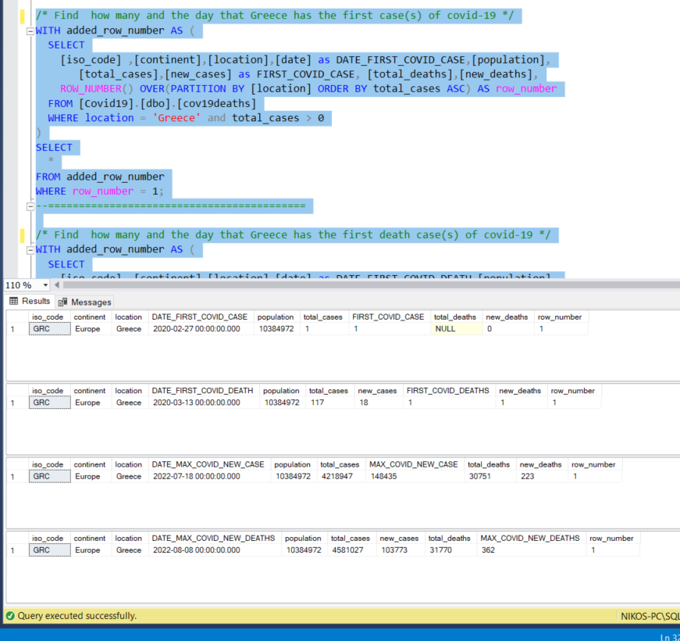

Vaccination Progress in Greece over Population (VPOP)

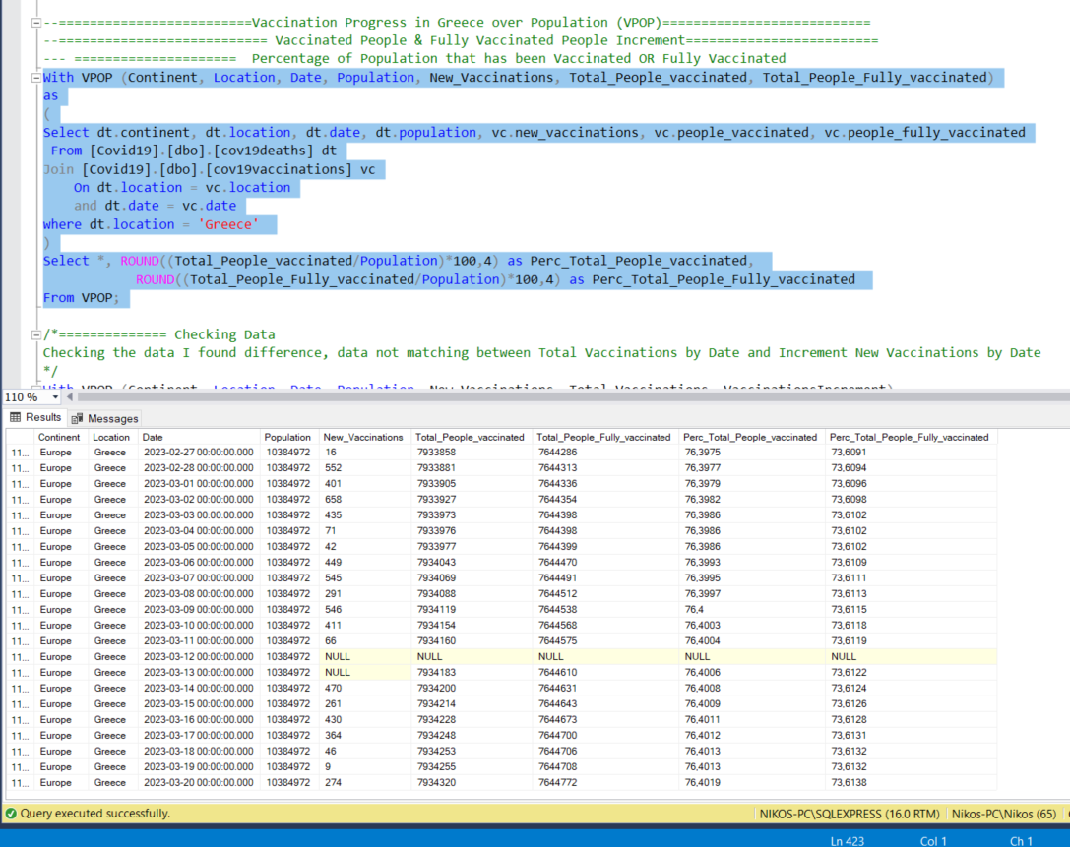

The results after performing queries regarding Greece are:

**COVID-19 Greece Information (up to 20/03/2023)**

**Last data update: 20/03/2023**

**Population: 10.384.972**

**Infections - Deaths**

**Total Covid Cases: 5.910.103**

**Infection Percentage: 56,91%**

**Total Deaths: 36.372**

**Death Percentage: 0,615%**

**First Covid19 Case: 27/02/2022**

**First death caused by Covid19: 13/03/2020**

**Date Max Covid New Cases: 18/07/2022**

**Max Covid New Cases: 148.432**

**Date Max Covid New Deaths: 08/08/2022**

**Max Covid New Deaths: 362**

**Vaccinations**

**Total Vaccinations(count): 22.115.771**

**First Covid19 Vaccinations: 447**

**Date First Covid19 Vaccinations: 28/12/2020**

**Total People Vaccinated: 7.934.320**

**Percentage Total People Vaccinated: 76,4019%**

**Total People Fully Vaccinated: 7.644.772**

**Percentage Total People Fully Vaccinated: 73,6138%**